

***School of Mechanical & Manufacturing Engineering (SMME),***

***National University of Science and Technology (NUST),***

***Sector H-12, Islamabad***

Program: BE-Aerospace Section: AE-01

Session: Fall 2023 Semester: 1st

Course Title: Fundamentals of Programming (CS-109)

***“Assignment”***

***Name: Sohaib Abdullah***

***CMS:*** 455368

1. Write a C++ program, take two strings as input from user and check if both strings are equal or not. If they are equal make them unequal by rotating string. e.g., Hello is turned into olleH etc.

* The program prompts the user to enter two strings.
* It checks if the entered strings are equal.
* If the strings are equal, it rotates the first string by moving the first character to the end.
* Displays whether the strings are now unequal.
* Shows the modified first string and the second string.

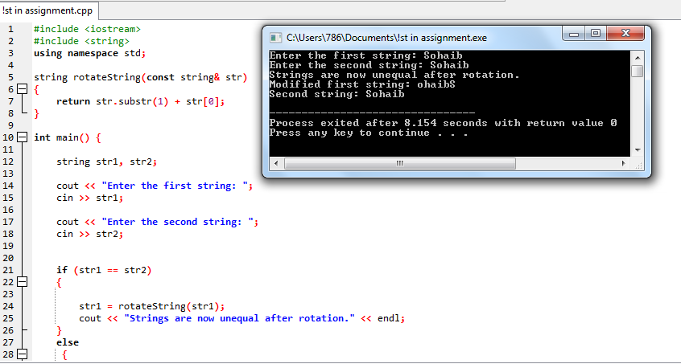

Figure :This program inverts string input

2. Write a C++program for a string which may contain lowercase and uppercase characters. The task is to remove all duplicate characters from the string and find the resultant string.

* This C++ program removes duplicate characters from a given string, considering both uppercase and lowercase characters.
* It utilizes an unordered set to track unique characters while iterating through the input string.
* The program then constructs and displays a resultant string containing only the unique characters in lowercase form.

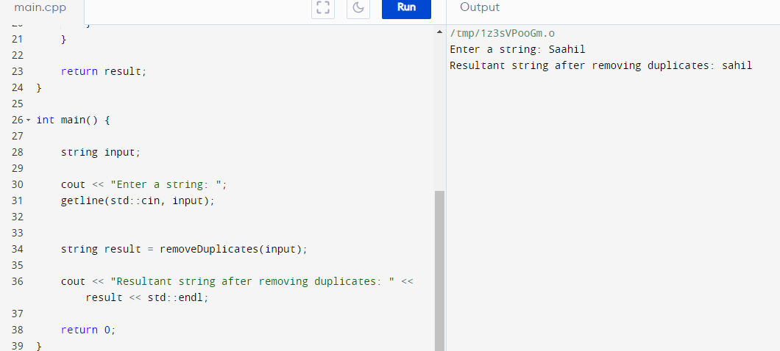

Figure : This program checks for repetition of characters and remove repeated characters

3. Suppose an integer array a[5] = {1,2,3,4,5}. Add more elements to it and display them in C++.

* An array is given to us.
* The program declares a new array.
* Elements of first array are copied to new array.
* Some new elements are introduced in array
* New array is displayed

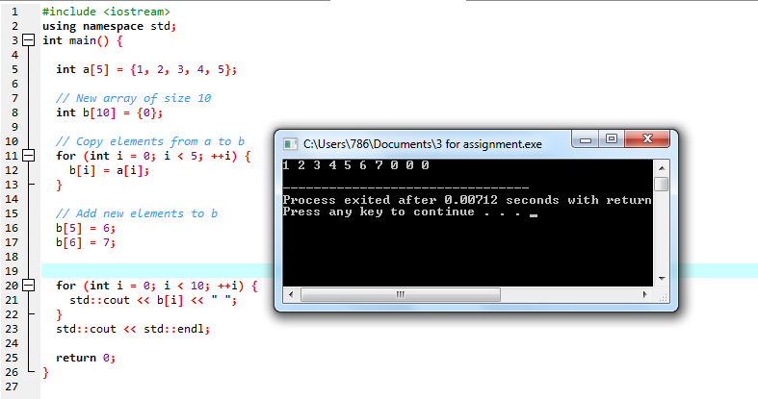

Figure : This program increases elements of an array and displays them

4. Write a C++ program that uses a while loop to find the largest prime number less than a given positive integer N. Your program should take the value of N as input from the user and then find the largest prime number less than or equal to N. You are not allowed to use any library or pre-existing functions to check for prime numbers.

* This program takes an integer as input from user.
* Then checks whether a number is prime or not
* If number is prime it displays the number.
* If number is not prime it displays a prime number less than given number.

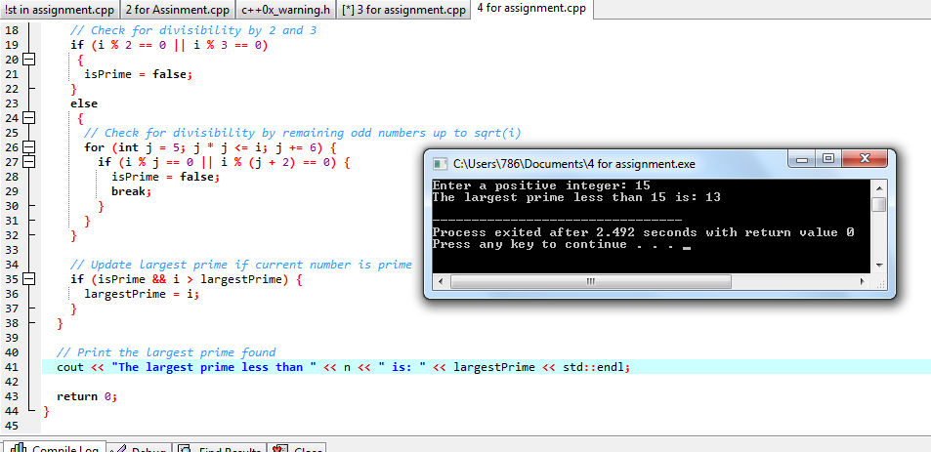

Figure :This program displays prime number less than given number

5. Implement Bubble Sort on an array of 6 integers.

* This program takes elements of an array from user.
* Than it arranges elements in ascending order.
* After sorting array it displays sorted array.

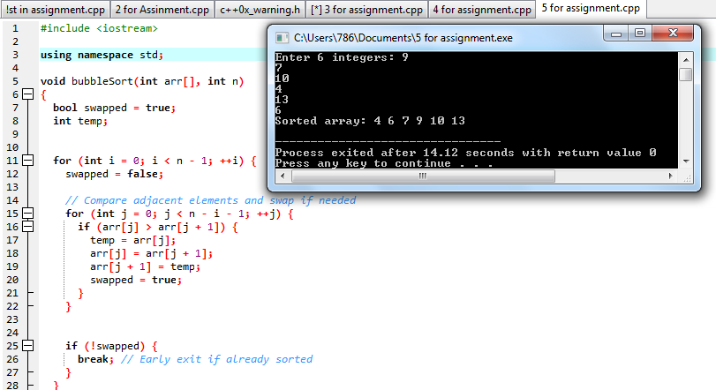

Figure : This program apply bubble sort t give array

6. Solve any Aerospace/Real Life Problem using C++ Programming

* This program takes wing span and area as input from user
* Than it calculates the aspect ratio of wing

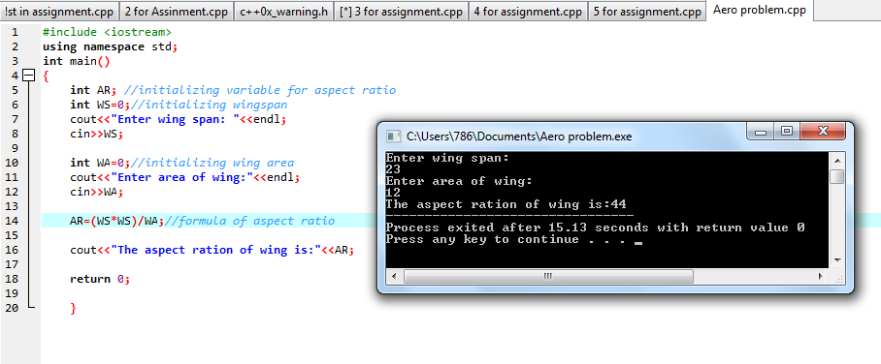

Figure : This program calculates aspect ratio of a wing